**Computer Graphics**

Animation project - Andrii Khudolii

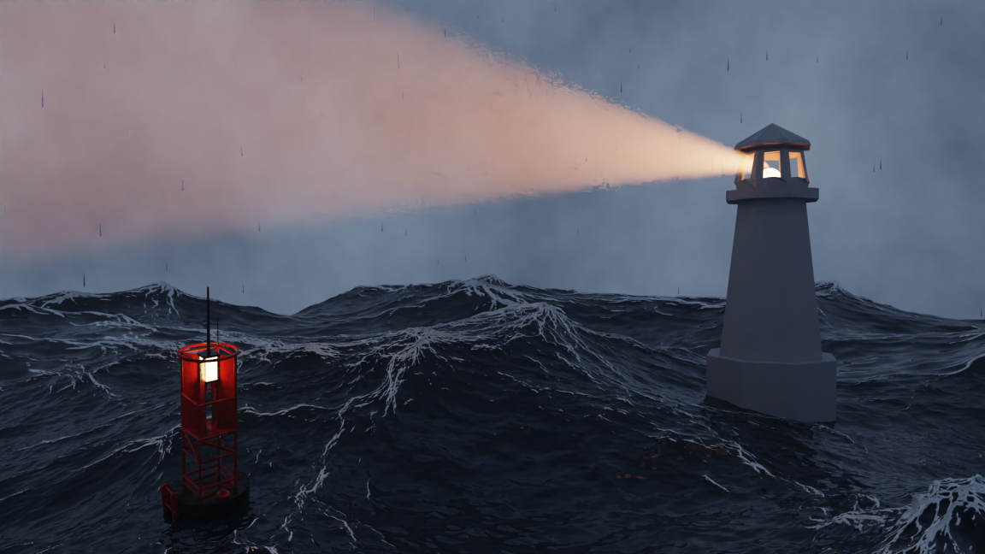

I’ve used an idea from [this](https://www.youtube.com/watch?v=oysCSbhXYBo) ocean tutorial. In summary, rendering took 6 hours for unoptimized version(60/250 frames was rendered) and ~2hours for optimized. I had to divide rendering in some smaller videos, because blender could crash anytime while rendering.

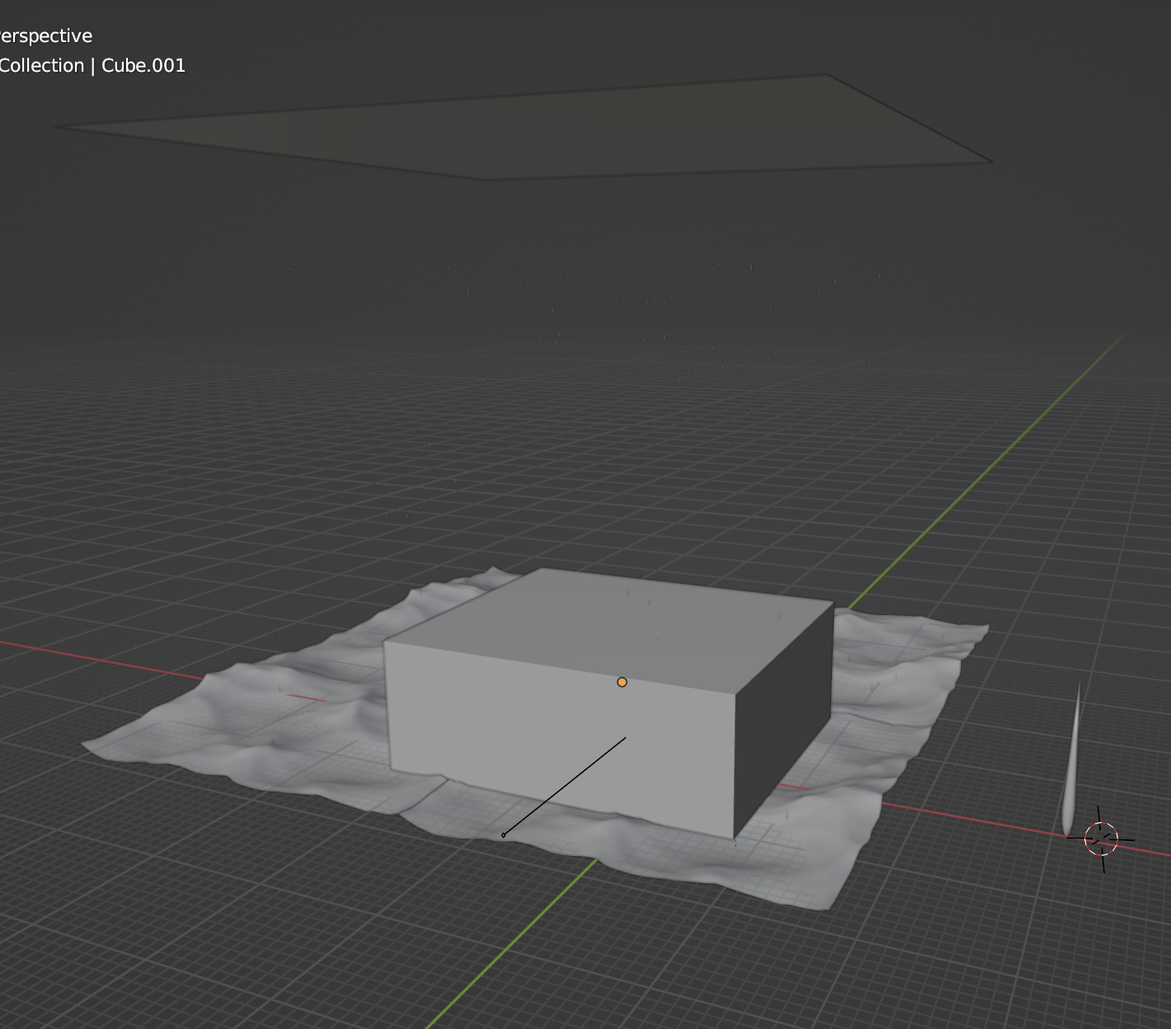

That’s how scene looks in viewport shading mode - without any texturing. In the center big cube is volume for volumetric lightning. It’s done for optimization mitigation, because global volumetric took soo much time to render.

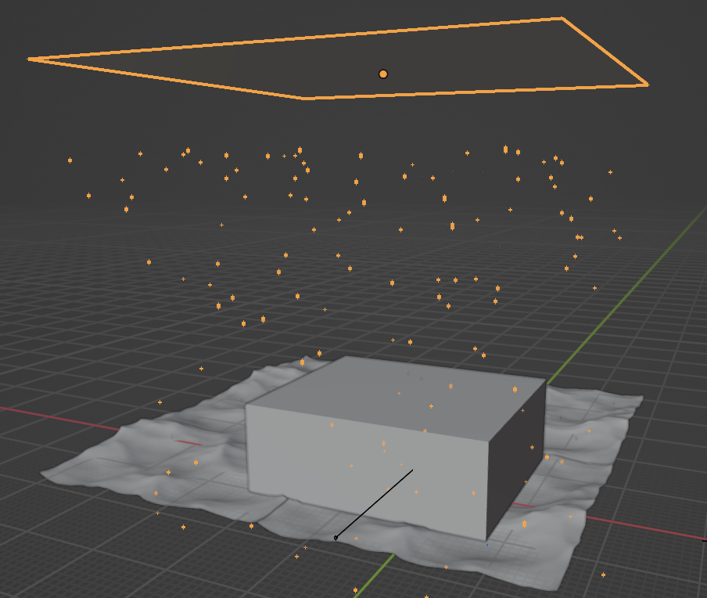On the top it is a particle system, that creates rain particles. Rain particle model was made by myself - it was not hard, just modified icosphere.

Ocean was created using Ocen modifier in object’ settings. I’ve followed previously mantioned tutorial to reach such beautiful result. On this ocean camera and buoy are floating using another objects with SchrinkWrap properties.

Right-bottom ocean square is high-poly one, and others a lowpoly - just for cool background.

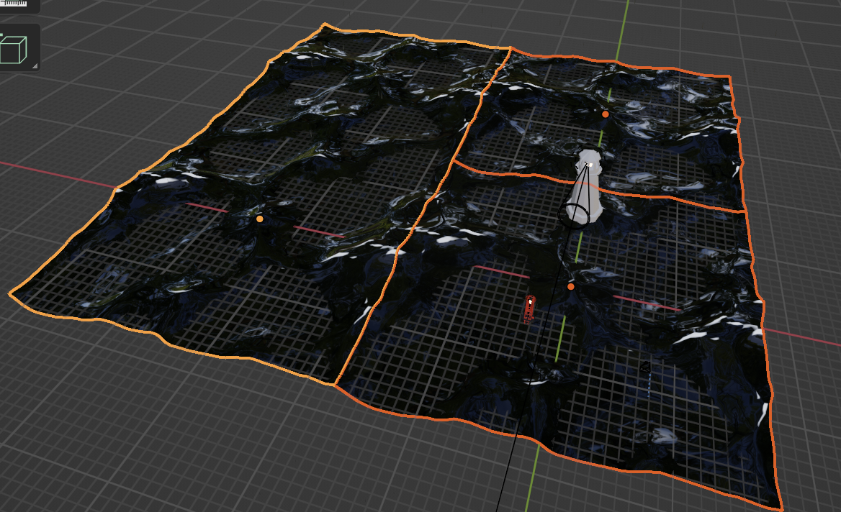

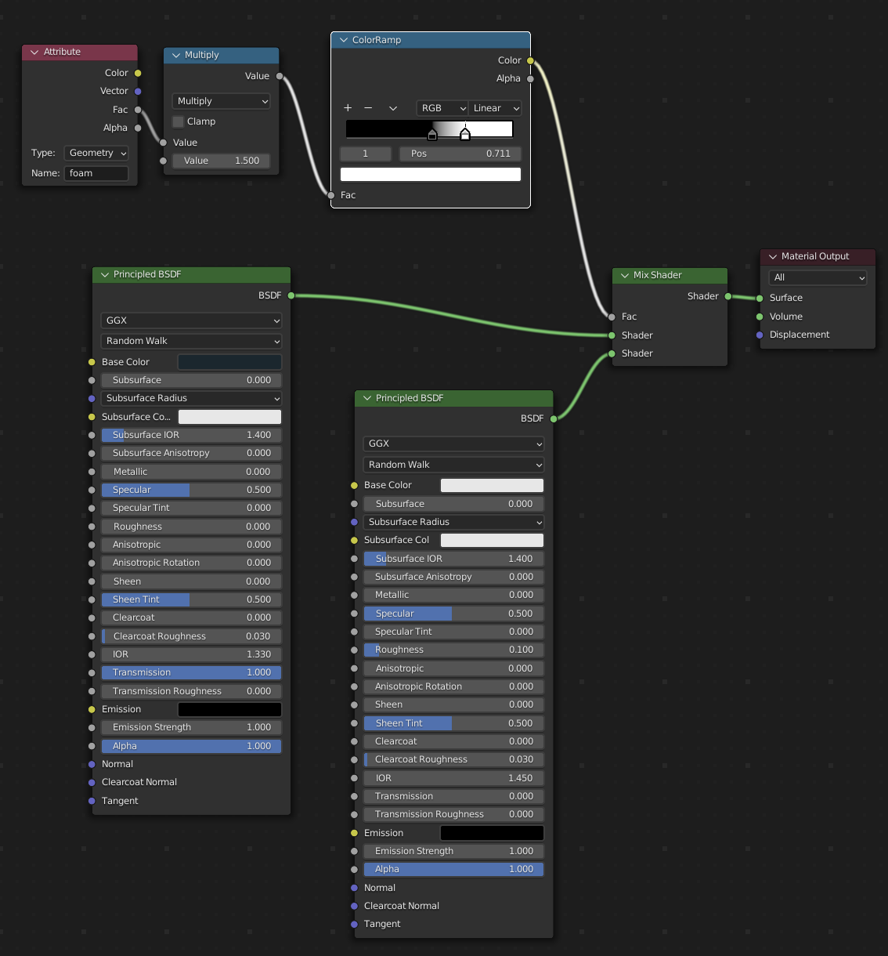

For ocean’s material been used shader maker, example at the bottom. It is using FAC property from ocean object, creates white texture parts at the hard edges of ocean.

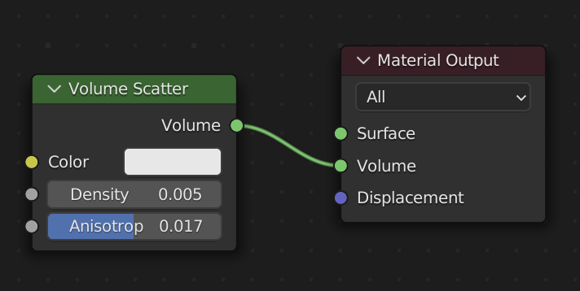

Then, after setting up all materials, volumetric cube looks like that. For that I’ve used Volume Scatter modifier in shader window.

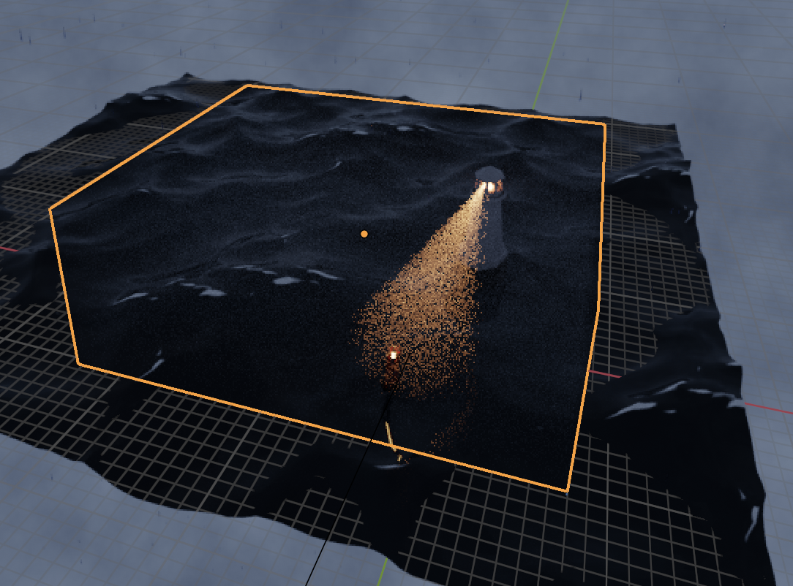

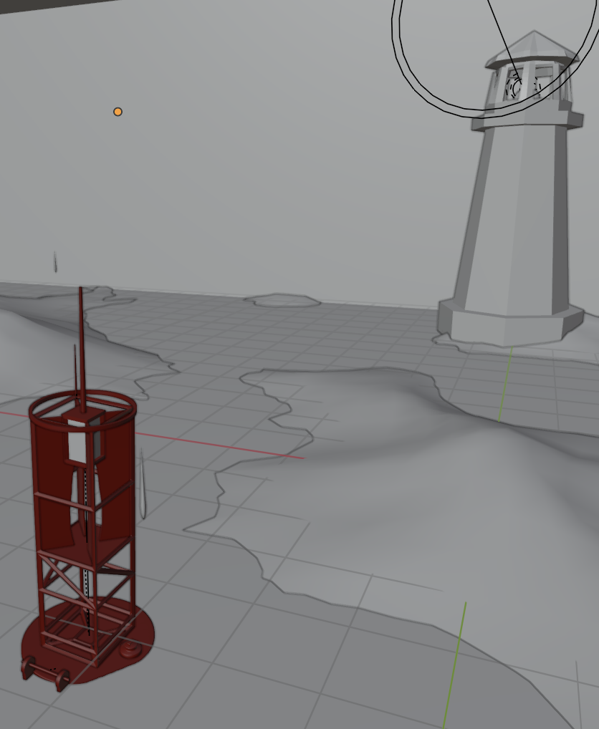Model of buoy was taken buy tutorial on youtube. It’s not made by me.

But a model of lighthouse was made by me. It doesn’t have much details and it should not, because it’s not on the front.

For creation of this geometry, vertex extrude, link, move, scale and Solidify parameters were used.

Inside of lighthouse, spotlight and sphere with emission were used.

Light was keyframe animated - set rotation every 30 frames.

And the last part - background. I’ve simply followed tutorial to add some rainy clouds, using noise and colorRamp nodes.

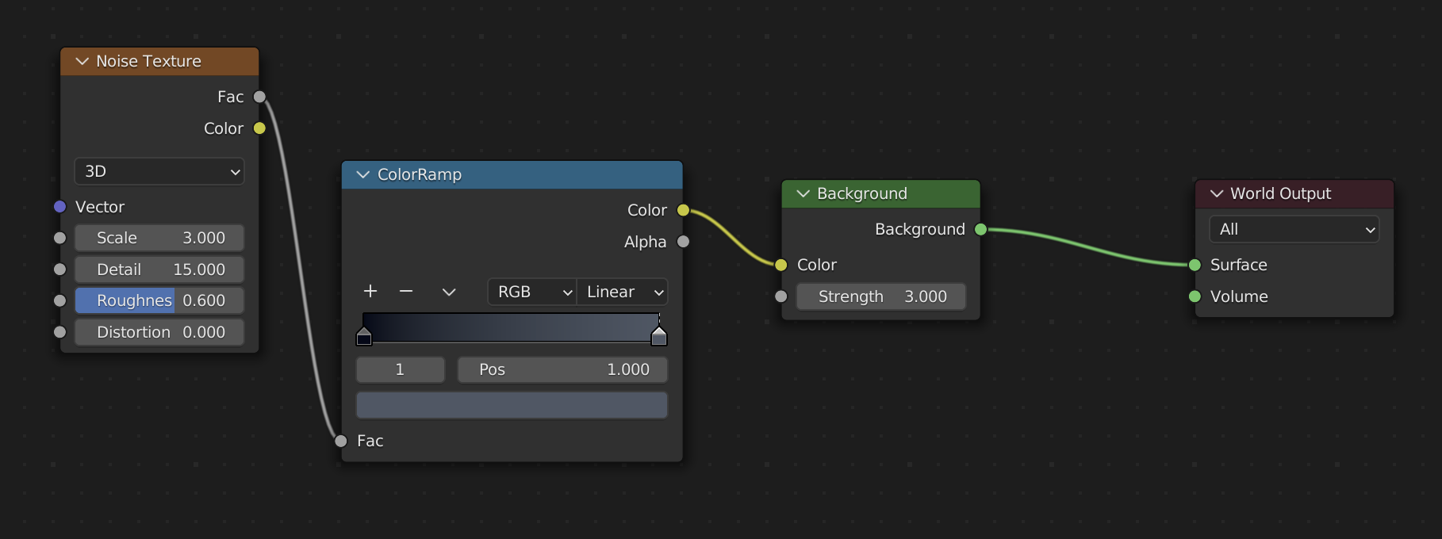

Then the hardest problem begun - toooooo slow rendering progress.Without any changes, blender had 60/250 frames rendered.

I thought that maybe on uni’s pc it would take lesst time to render. But for suprisingly on that pc it took muuuuch more time than on my laptop. On the left image it’s estimated time of rendering me one Image. And on the right- rendering time for the same frame,

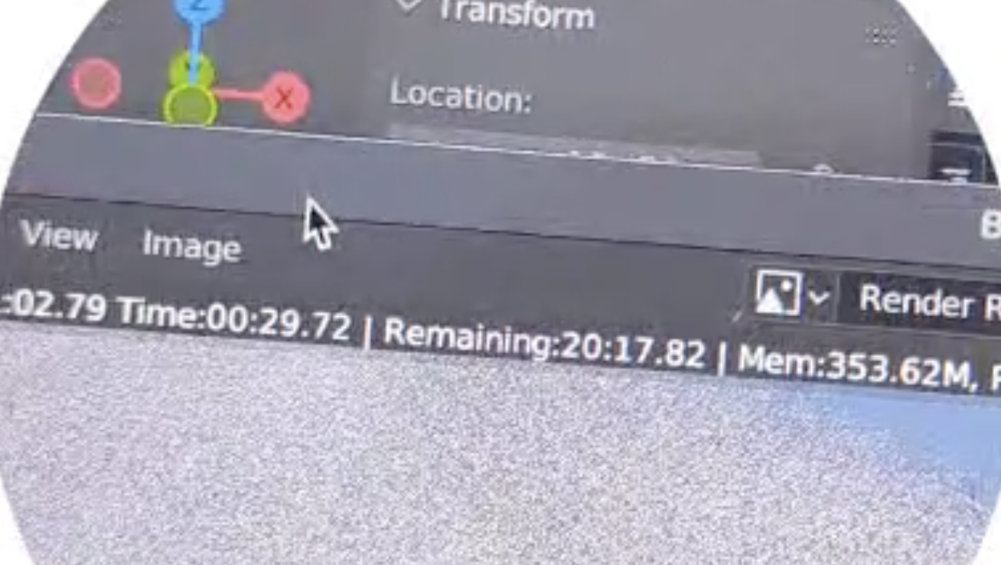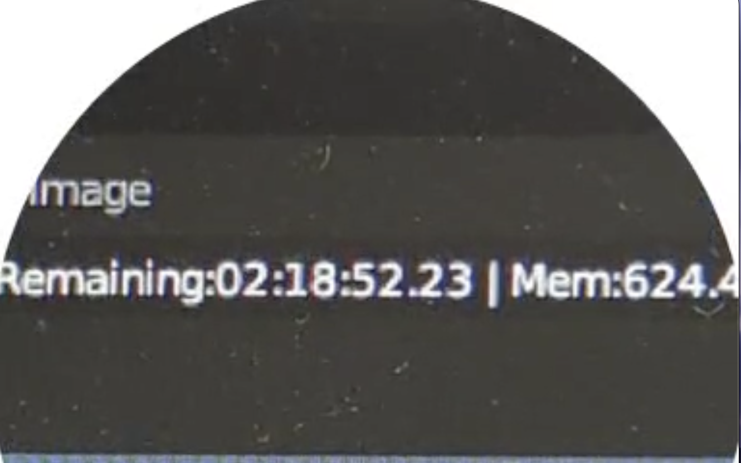

Than I had to optimize rendering process.

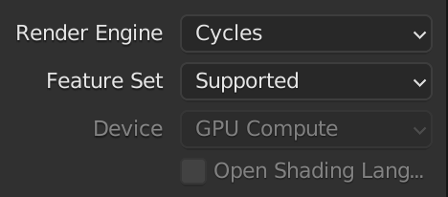For rendering Cycles render engine was used.

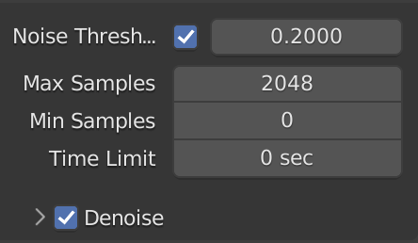

I’ve used “noise threshold” to decrease time of rendereing each frame. Also I.ve double-mitigated “Max samples” paramter. It haven’t change the quality of rendering at all.

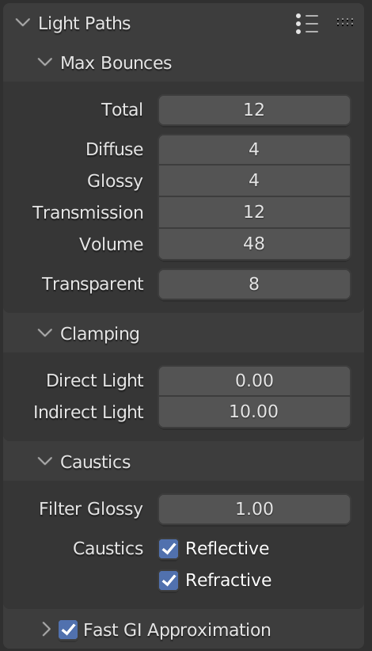

Then, “Volume steps” needs to be added so I could see working volumetric lightds. I’ve setted it to the 48 parameter. I think I could decrease it 2 times without losing much quality.

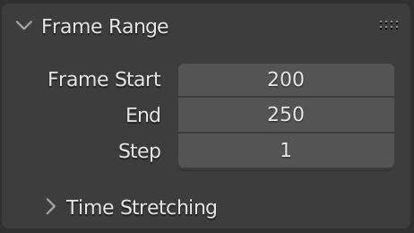

Output animations were generated separately because Blender could crush by rendering, so it’s better to already have a part completed. I read that it’s possible to export every frame of it, but I decided to split animation in 3 videos(100\100\50 frames).